# Integration with GitHub

In the previous chapter we discussed how to integrate Visual Studio Code and Visual Studio Online but if you like GitHub or any other Git provider you can use it as well. Let’s see how to start using GitHub.

If you still don’t have a GitHub account you can visit github.com site and create one. Once you have a GitHub account you can create a new repository or use an existing one. In my case I have created a new repository clicking New Repository button on the main page.

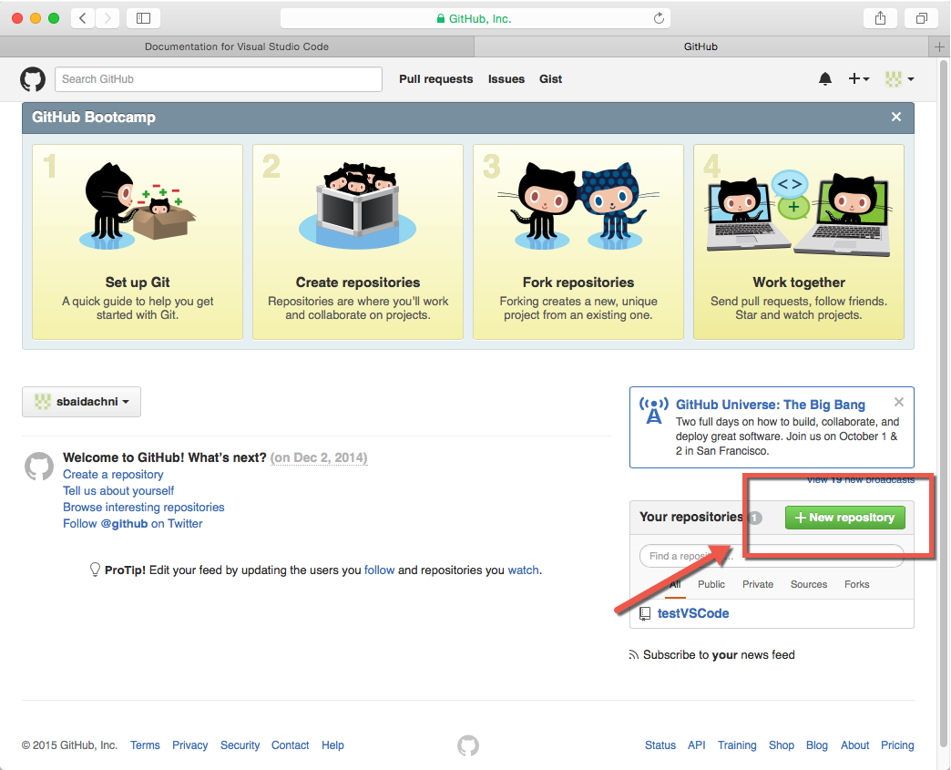

To create a new repository you simply need to provide a name and you can initialize the repository with readme file. But pay special attention that GitHub supports public free repository by default and if you want to create a private repository you need to pay or switch to Visual Studio Online.

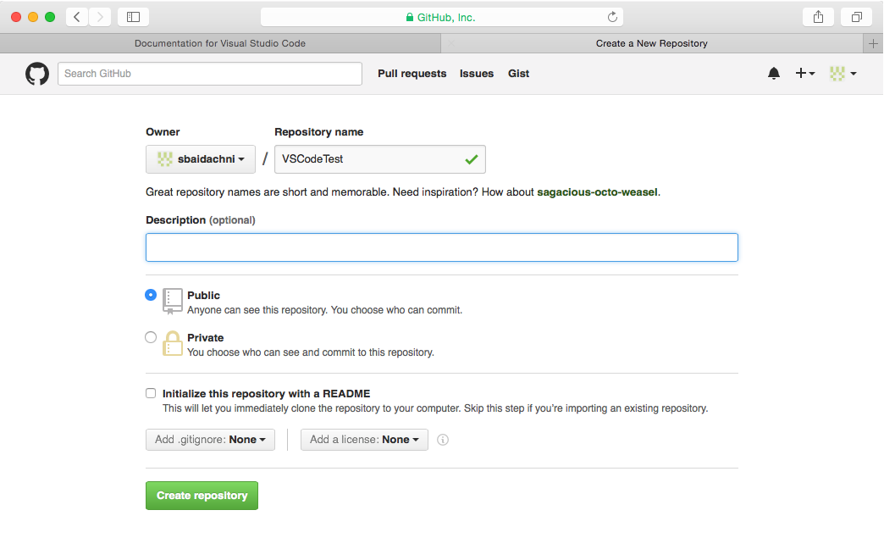

Once your repository is created, you can navigate it and copy the link for cloning what we are going to use in order to initialize our Git system:

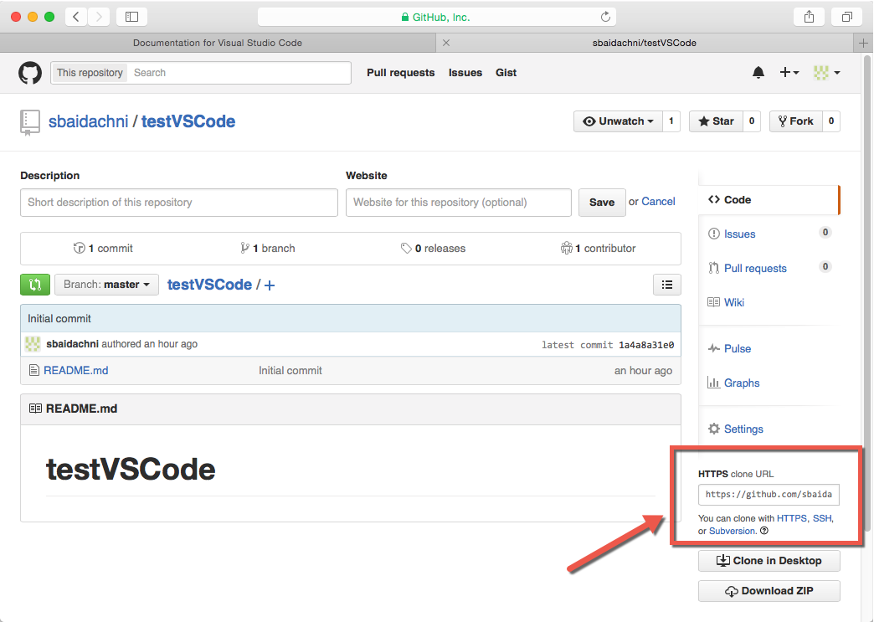

At the next step you need to open Terminal window in order to setup GitHub as a remote repository. In order to open Terminal window I often use Code context menu by clicking any file in Explore sidebar but if you don’t have any files you still can open Terminal window from Code directly. In order to do it you need to activate Command Palette using View menu item or ⇧⌘P hot keys combination. Using Command Palette you can call Terminal window in context of the folder:

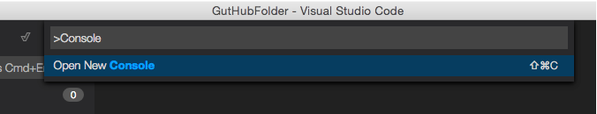

But pay special attention that in this case Terminal window doesn’t have context of working folder. So, you need to navigate it manually.

Using Terminal window you can associate git with a user name that will be shown in commits history:

**git config --global user.name sbaidachni**

And clone the GitHub repository to the local folder using the link which we copied earlier:

**git clone** [**https://github.com/sbaidachni/testVSCode.git**](https://github.com/sbaidachni/testVSCode.git)

If operation is successful, you should see something like this:

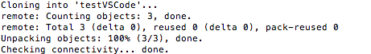

It’s time to associate GitHub repository as a remote repository. We can do it by using the same command that we used when adding Visual Studio Online repository:

**git remote add origin https://github.com/sbaidachni/testVSCode.git**

You can check that operation is successfully finished when checking existing remote repositories:

**git remote -v**

In my case the command prints the following information:

**origin https://github.com/sbaidachni/testVSCode.git (fetch)**

**origin https://github.com/sbaidachni/testVSCode.git (push)**

Finally, In order to avoid problems with login, you need to execute the credential helper:

**git config --global credential.helper osxkeychain**

That’s all and now you can use Visual Studio Code to open just cloned folder. Code will read all information about the repository automatically and you can simply start coding.